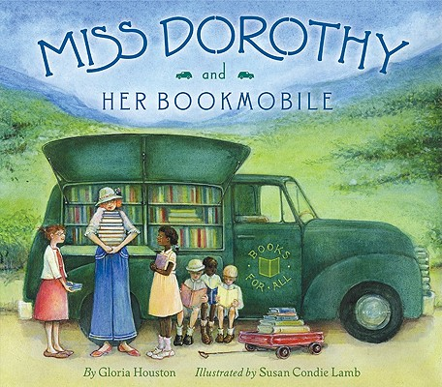

**Miss Dorothy and Her Bookmobile**

The team behind

**My Great-Aunt Arizona**

**proudly presents**

Release: 1/5/11 ⬩ On Sale: 1/25/11

ISBN: 978-0-06-029155-6 ⬩ Price: $16.99 ($18.99 CAN)

*When Dorothy was a young girl,*

*she loved books, and she loved people,*

*so she decided that she would become a librarian.*

Dorothy’s dearest wish it to be a librarian in a fine brick library just like the one she visited when she was small. But her new home in North Carolina has valleys and streams but no libraries, so Miss Dorothy and her neighbors decide to start a bookmobile. Instead of people coming to a fine brick library, Miss Dorothy can now bring the books to them—at school, on the farm, even once in the middle of a river!

Miss Dorothy and Her Bookmobile is an inspiring story about the love of books, the power of perseverance, and how a librarian can change people’s lives.

************

**“T**he story follows one woman’s dedication to bringing reading material to people in the Blue Ridge Mountains of North Carolina …. A lovely addition to any collection.”—*School Library Journal*

“**H**ouston writes with a knowing, warm tone about a woman who touched the lives of many and cherished the ripple effect of her actions.”—*Publishers Weekly*

************



Gloria Houston draws on her own Appalachian background to create memorable picture books with a mountain setting. MY GREAT-AUNT ARIZONA was an ALA Notable Book of 1993, an IRA/CBC Children’s Choice, and an IRA Teacher’s Choice. A teacher and popular speaker, Gloria is an active promoter and a recognized expert in Appalachiana.



Susan Lamb has illustrated several other picture books for children, including the beloved MY GREAT-AUNT ARIZONA. Now writing and illustrating her own projects, Susan lives in Connecticut.



Illustrations copyright © 2011 by

Susan Lamb